Contents

1. Creating a new calendar 3
2. Editing an existing calendar 4
3. Deleting a calendar 5

Document Version Control
Change History/Review Details
Date | Version | Review by | Summary of Change
 | 1.0 | HC | Created following the implementation of ESS
Dec20 | 1.1 | HC | Updated following the switch to V28
20-APR-2022 | 1.2 | MJOS | Insert navigation steps for Quick Jump - Admin Settings

On the Employee Self Service landing page the next Pay Day is displayed under ‘Important Dates’. This relies on Payroll calendars held in the Portal for each pay group paid through the Payroll module.

In December each year new calendars must be created for the following year. It is not possible to overwrite an existing calendar with dates for the following year so new calendars must be created. It is possible to have more than one calendar for each pay group.

In December, before the December Pay Date, create a new calendar for each pay group for the whole following year (12 payment dates) following the steps in Section 1 - Creating a new calendar.

In January, before the January Pay Date, delete the calendars for the previous year following the steps in Section 3 - Deleting a Calendar.

NB: The Next Pay Date section in the Portal will be blank until the new calendars have been created.

NB: After the December payroll run, the pay day in ESS under Important Dates should update to the January’s pay date automatically - as part of Payroll team’s final monthly pay jobs there is a flag that should be selected to update the pay dates.

Core Portal > Employee Dashboard

First you need to switch to the classic interface to access the Additional Admin Settings.

- Go to Account Settings under your user profile | 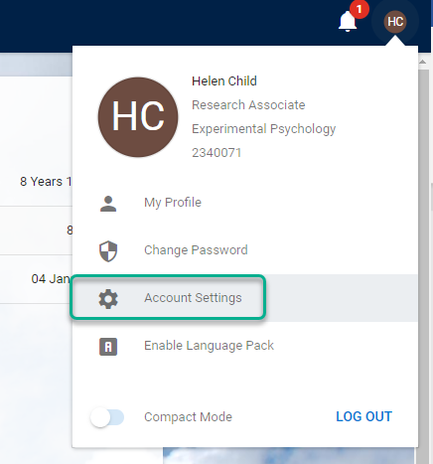
- Toggle to switch to the Classic UI | 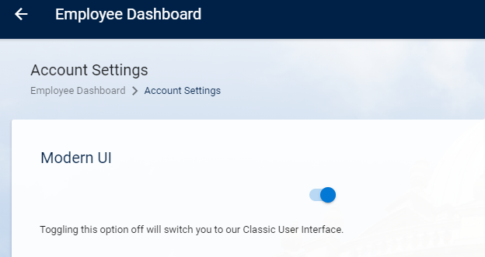
- Click OK | 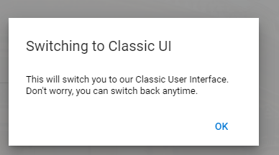

 | NB: Don’t forget to switch back once you’ve made the updates.

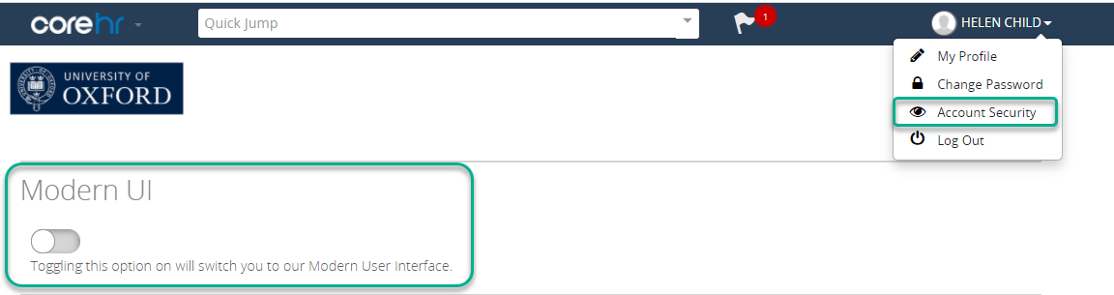

Using the Quick Jump menu select Admin Settings



Scroll down to the Core Portal Additional Parameters section and click on ‘Payroll Calendar Parameters’.

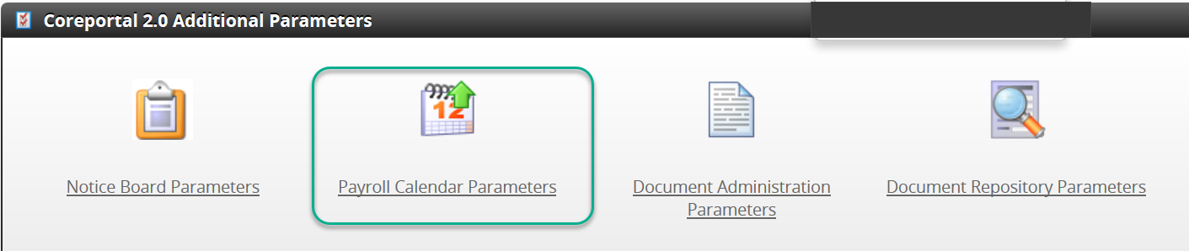

Creating a new calendar

  - Click on ‘Create CorePayroll Calendar Dates’

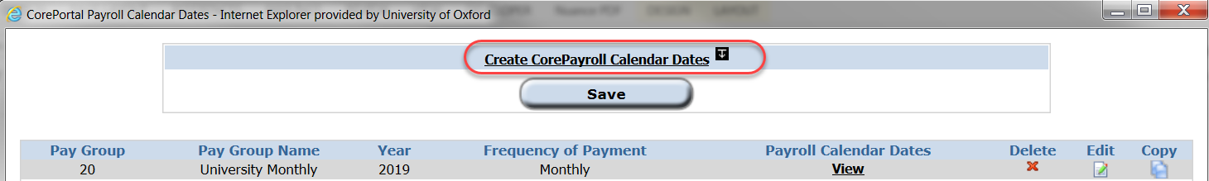

  - The Calendar display form will open:

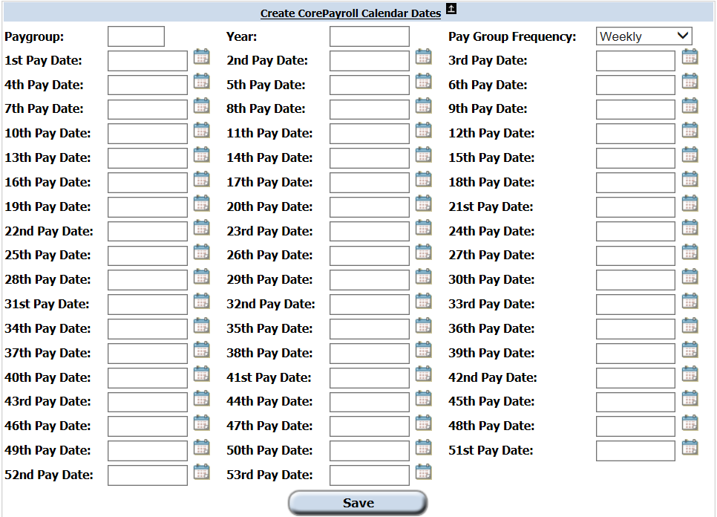

  - Enter the details as follows:
Field | Description
Pay Group | Enter 20 or 21 as applicable
Year | Enter year as required
Pay Group Frequency | Select ‘Monthly’
  Pay Dates | Enter 1st to 12th Pay Dates inclusive where 1st Pay Date = January.  NB it’s important to add all 12 dates even if you have already entered the January Pay Date into the previous year’s calendar.

  - Click on .

  - To view a calendar click on ‘View’ below Payroll Calendar Dates.

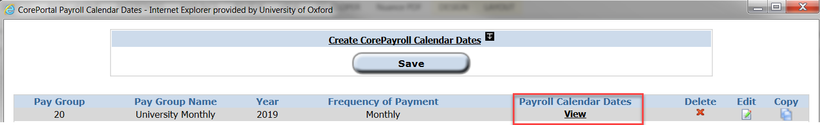

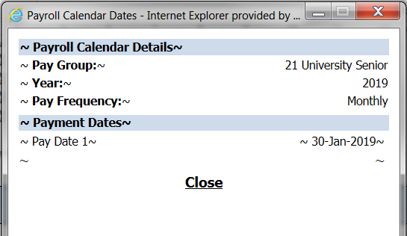
  - A pop up window will open showing the calendar details and the payment dates entered.

Editing an existing calendar

 | NB: You should only need to edit existing dates if a published Pay Date has been changed by Payroll for some reason.

  - To edit an existing calendar click on Edit .

The Calendar view will open:
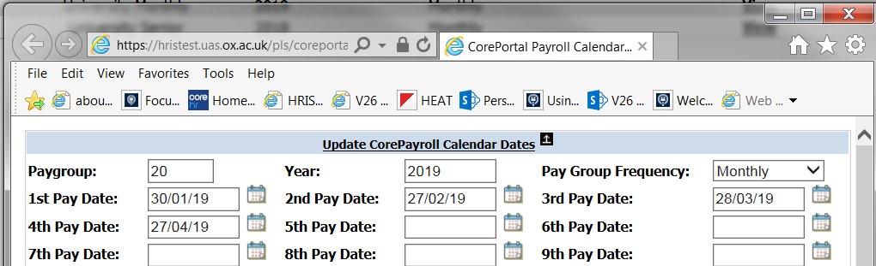

  - You can overwrite an existing date or add a new date as required.

 | NB: Dates must be entered in the format as shown (dd/mm/yy) or selected from the calendar.

  - Click on .

Deleting a calendar

  - To delete a calendar click on the ‘Delete’ button in the relevant row.

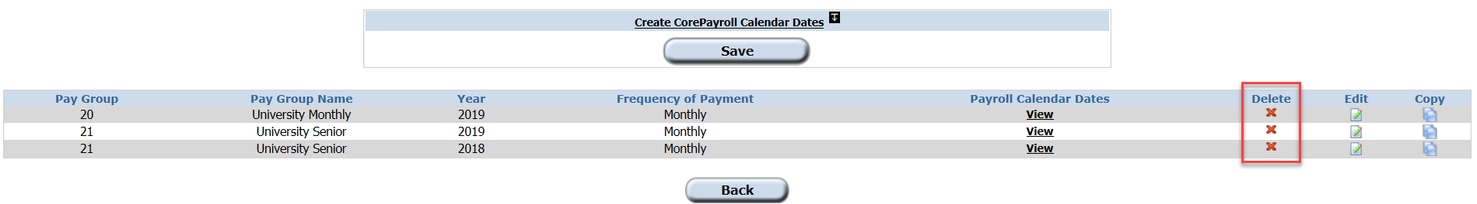

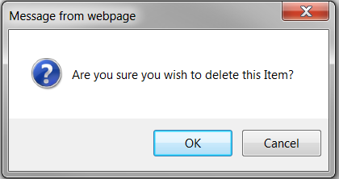
  - A warning message will appear.

  - Click  to delete.

Knowledge Article: Employee Self Service

